The onus of the authenticity of the information lies with the Institution ONLY and not on AICTE.

- NAME OF THE INSTITUTION : Kanak Manjari Institute of Pharmaceutical Sciences,
Address including telephone, Mobile Chhend, Rourkela-769015, 0661-2480752,
E.mail 2480756, 2480031
: info@kmips.com, kmips_p@rediffmail.com

- Name and address of the Society and the Trustees: Kanak Manjari Institute of Pharmaceutical
Address including Telephone, Mobile, E-Mail Sciences, B/29 Industrial Estate, Rourkela-4
Mob- 9437040521
Sl.  No | Name | Address | Qualification | Profession
01 | Mr. B.R. Patnaik, Chairman | Plot.No-BB/16,Civil Township  Rourkela-4,Dist-Sundargarh | BSc, LLB | Industrialist
02 | Mrs. Shree Patnaik, Vice-Chairman | Plot.No-BB/16,Civil Township  Rourkela-4,Dist-Sundargarh | MBA | Educationist
03 | Mr. P. K. Das, Secretary | Qrs.No-HIG/43,Chhend colony,  Rourkela-15, Dist-Sundargarh | BSc(AG) | Educationist
04 | Mrs. Gitashree Das,Member | Qrs.No-HIG/43,Chhend colony,  Rourkela-15, Dist-Sundargarh | BA | Social Worker
05 | Mr. Abhiseka Patnaik,Member | Plot.No-BB/16,Civil Township  Rourkela-4,Dist-Sundargarh | MBA | Industrialist
06 | Mr. S.R. Nayak, Member | Kafala , Cuttack | BA | Business
07 | Mr.Madhabananda Nayak, Member | Birajapally,Uditnagar, Rourkela | Matric | Care Taker
08 | Mr. S. S. Bera, Member | Qr.No. M/16, Chhend,Rourkela-769015 | B.A | Clerk
09 | Mr. Prasanna Kumar Nanda, Member | Khariabahal, Sector-2, Rourkela-6, Sundargarh | D. Pharm | Office Asst.
- Name and Address of the Principal : Prof.(Dr.)Biswaranjan Behera,
Address including Telephone, Mobile, E-Mail M.Pharm, Ph.D
Chhend,Rourkela-15,Ph-0661-2480031, 9437158897, prof.brbehera@gmail.com
- NAME OF THE AFFILIATING UNIVERSITY : Biju Patnaik University of Technology,
Chhend, Rourkela-15, Dist- Sundargarh,
Odisha, PIN-769015
Ph-0661-2501345(Fax), 2501346,2501347
- GOVERNANCE
  - Members of the Board and their brief back ground
Sl.No | Name | Designation | Qualification | Profession
01 | Mr. B.R. Patnaik | Chairman | BSc, LLB | Industrialist
02 | Mrs. Shree Patnaik | Vice-Chairman | MBA | Educationist
03 | Prof.(Dr.) Biswaranjan Behera, Principal, KMIPS, Rourkela | Member Secretary | M.Pharm, Ph.D | Educationist
04 | Prof.(Dr.) Subhashree Sahoo, KMIPS, Rourkela | Member | M.Pharm, Ph.D | Educationist
05 | Mr. Pradyut Kumar Das | Member | B.Sc.(AG) | Educationist
06 | Mrs. Gitashree Das | Member | BA | Social worker
07 | Mr. Abhiseka Patnaik | Member | MBA | Industrialist
08 | Mr.Vikash Dash | Member | M.Pharm | Educationist
09 | Prof. (Dr.) Raj Kishore Patel, Professor | Member |  | Educationist
10 | Mr. Pradeep Kumar Bal | Member
11 | Regional office, AICTE, Kolkata | Ex- Officio Member
12 | Director of Technical Education & Training, Odisha | Ex- Officio Member
13 | Nominee of Biju Patnaik University of Technology, Rourkela | Ex- Officio Member
* Members of Academic Advisory Body
Sl.No | Name | Qualification | Specialization
01 | Prof.(Dr.) Biswaranjan Behera, Chairman | M.Pharm, Ph.D | Pharmacognosy
02 | Prof.(Dr.) Manoj Kumar Dalai, Co-ordinator | M.Pharm, Ph.D | Pharma. Chemistry
03 | Prof.(Dr.) (Mrs.) Subhashree Sahoo, Member | M.Pharm, Ph.D | Pharmaceutics
04 | Dr. Prakash Kumar Palai, Member | M.Pharm, Ph.D | Pharma. Chemistry
05 | Dr. Manoj Kumar Mohapatra, Member | M.Pharm, Ph.D | Pharma. Chemistry
06 | Prof. Ashok Kumar Samanta, Member | M.Pharm | Pharmaceutics
07 | Dr. Itishree Mohanty, Member | Ph.D | Management
08 | Miss Sarojini Nayak, Member | M.Pharm | Pharmacology
* Frequency of the Board Meeting and academic Advisory Board Meeting -Thrice in a year
Academic Advisory Body- Four times in a year

Organizational Chart and Process of
kanak manjari institute of pharmaceutical sciences,
chhend, rourkela

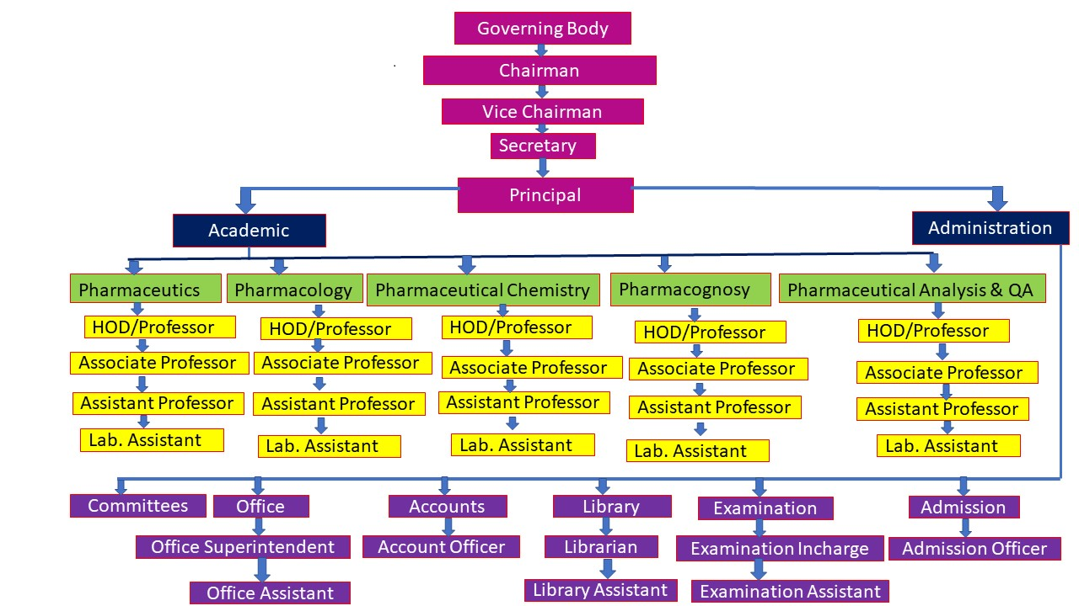

- Nature and Extent of involvement of Faculty and students in academic affairs/improvements
The following committees/Forum are constituted
  - Academic Planning and evaluation Committee
  - Co-Curricular and extracurricular Committee

Academic Planning and evaluation Committee
Objectives – Academic Planning and evaluation
Frequency of meeting -Twice a year
Constitution -
- Prof.(Dr.) Biswarnjan Behera, Chairman
- Prof.(Dr.) (Mrs.) Subhashree Sahoo, Member
- Prof.(Dr.) Manoj Kumar Dalai, Co-ordinator
- Dr. Prakash Kumar Palai, Member
- Dr. Manoj Kumar Mohapatra, Member
- Prof. Ashok Kumar Samanta, Member
- Miss. Sarojini Nayak, Member
- P.G Student Nominee
- 10.P.G Student Nominee
- 11.UG Student Nominee
- 12. UG Student Nominee

Co-Curricular and extra curricular Committee
Objectives – Academic Planning and evaluation
Frequency of meeting -Twice a year
Constitution -
1.Dr. Itishree Mohanty, Member
2.Mr. N. R. Parida
3.Mr. Vikash Dash
4.P.G Student Nominee
5.P.G Student Nominee
6.UG Student Nominee
7.UG Student Nominee

- Mechanism/ Norms and Procedure for democratic/ good Governance: Yes
- Student Feedback on Institutional Governance/ Faculty performance: Yes
- Grievance Redressal mechanism for Faculty, staff and students: A Grievance redressal
Committee is constituted. The Grievances are heard and disposed of once in a month: Yes
- Establishment of Anti Ragging Committee: Yes
- Establishment of Online Grievance Redressal Mechanism: Yes
- Establishment of Grievance Redressal Committee in the Institution and Appointment of
OMBUDSMAN by the University: Yes
- Establishment of Internal Complaint Committee (ICC) : Yes
- Establishment of Committee for SC/ ST: Yes
- Internal Quality Assurance Cell: Yes

Administration Process
The administrative process takes care of the management and administration of the institute as a whole. The important functions of the process are

  - Manpower Planning
  - Wage and Salary Administration
  - Labours Welfare and Social Security.

Every year, a manpower demand plan is worked out for each department for both Diploma, UG and PG level in order to ascertain the requirement of faculty and qualification wise. Such exercise is made by taking the AICTE/PCI norms into consideration. Similar exercise is also made for non-teaching and technical personnel.

Advertisements are released for recruitment. Selection committees are constituted for the recruitment.

Salary is paid as per AICTE norms. Facilities like E.P.F, ESIC are implemented. Faculty Development Programmes, Sponsoring Faculty for M.Pharm and Ph.D Programmes under QIP of AICTE are some welfare amenities provided by the institute.

Academic Process

The institute imparts education in Pharmacy at PG(M.Pharm), UG (B.Pharm) and D.Pharm level.
For M.Pharm the input of the process are drawn from OJEE, Odisha.
For B.Pharm the inputs of the process are drawn from OJEE, Odisha.
For D.Pharm the inputs of the process are drawn from Odisha State Govt. Counseling.

The academic curriculum designed by BPUT for UG and PG course and PCI for Diploma course. The students are evaluated by continuous evaluation process and appear examination in impartial Centers. The degree curriculum is of 4years in 8 Semesters, P.G curriculum is of 2 years in 4 Semesters and D. Pharm curriculum is of 2 years and 3 months hospital training. On successful completion of the course the degree/diploma is awarded by the University/ OSBP to the students as an output of the academic Process.

- PROGRAMMES

* Name of the Programmes approved by AICTE- D.Pharm, B.Pharm M.Pharm(Pharmaceutics) and M.Pharm(Pharmacology)

* Name of the Programmes accredited by AICTE- (Applied for B. Pharm and inspection
completed)
    - Status of Accreditation of the Courses
    - Total number of Courses
    - No. of Courses for which applied for Accreditation
    - Status of Accreditation –Results of the visit awaited for B.Pharm Course

* For each Programme the following details are to be given
- Name- D.Pharm
  - Number of Seats-60
- Duration- 2 years and 3 months
- Cut off marks/rank of admission during the last three years: As per Odisha State Govt.
- Fee- Rs.62,000/-Per Year.
- Placement Facilities- Available
- Campus placement in last three years with minimum salary, maximum salary and average salary- 2019-20- Min. Sal-15,000/- Max. Salary – 20,000/-,2020-2021-Min. Sal-18000/- Max.Salary-20,000/-, 2021-2022-Min. Sal-18,000/- Max.Salary-20,000/-

For each Programme the following details are to be given
- Name- B.Pharm
- Number of Seats-100
- Duration- 4years (8semesters)
- Cut off marks/rank of admission during the last three years: As per OJEE,Odisha
- Fee- Rs.62,500/-Per Year.
- Placement Facilities- Available
- Campus placement in last three years with minimum salary, maximum salary and average salary- 2019-20- Min. Sal-15,000/- Max. Salary – 20,000/-,2020-2021-Min. Sal-18000/- Max.Salary-20,000/-, 2021-2022-Min. Sal-18,000/- Max.Salary-20,000/-

* For each programme the following details are to be given
- Name- M. Pharm(Pharmacology)
- Number of Seats-18
- Duration- 2years(4semesters)
- Cut off marks/rank of admission during the last three years: As per OJEE, Odisha
- Fee- Rs.73,000/- Per Year.
- Placement Facilities- Available
- Campus placement in last three years with minimum salary, maximum salary and average salary- 2019-2020 Min. Salary- 30,000/-per month, Max. Salary – 35,000/-per month
* For each programme the following details are to be given
- Name- M. Pharm(Pharmaceutics)
- Number of Seats-18
- Duration- 2years(4semesters)
- Cut off marks/rank of admission during the last three years: As per OJEE,Odisha
- Fee- Rs. 73,000/- Per Year.
- Placement Facilities- Available
- Campus placement in last three years with minimum salary, maximum salary and average salary- 2019-2020 Min. Salary- 30,000/-per month, Max. Salary – 35,000/-per month

Name and duration of programme(s) having Twinning and Collaboration with Foreign University(s) and being run in the same Campus along with status of their AICTE approval. If there is Foreign Collaboration, give the following details: Nil
- Details of the Foreign University
- Name of the University
- Address
- Website
- Accreditation status of the University in its Home Country
- Ranking of the University in the Home Country
- Whether the degree offered is equivalent to an Indian Degree? If yes, the name of the agency
- Which has approved equivalence. If no, implications for students in terms of pursuit of higher
- studies in India and abroad and job both within and outside the country
- Nature of Collaboration
- Conditions of Collaboration
- Complete details of payment a student has to make to get the full benefit of Collaboration

For each Programme Collaborated provide the following: Nil
- Programme Focus
- Number of seats
- Admission Procedure
- Fee
- Placement Facility
- Placement Records for last three years with minimum salary, maximum salary and average salary
- Whether the Collaboration Programme is approved by AICTE? If not whether the Domestic/Foreign University has applied to AICTE for approval
7. Faculty
Branch | Permanent Faculty | Adjunct  Faculty | Permanent Faculty: Student Ratio | Number of Faculty employed and left during the last three years
D.Pharm | 06 | - | 1:20 | 01
B.Pharm | 24 | - | 1:15 | 03
M.Pharm (Ph.Ceutics) | 04 | - | 1:10 | 01
M.Pharm (Ph.Cology) | 04 | - | 1:10 | 01

i. Name : PROF.(DR.) BISWARANJAN BEHERA  ii. Date of Birth : 04.07.1973  iii. Unique id: 622577945451  iv. Education Qualifications: M.Pharm, Ph.D  v. Designation: Professor & Principal  vi.Work Experience:  - Teaching: 25Years  - Research:  - Industry:  - Others:  vii. Area of Specialization : Pharmacognosy  viii. Courses taught at Diploma/Under Graduate/ Post Graduate: D.Pharm & B.Pharm  ix. Research guidance  - No. of papers published in National : 13  /International Journals/ Conferences  - Master:15  - Ph.D: 03 (Continuing)  x. Projects Carried out: Nil  xi. Patents:Nil  xii. Technology Transfer:Nil  xiii. Research Publications:13  xiv. No. of Books published with details:Nil | 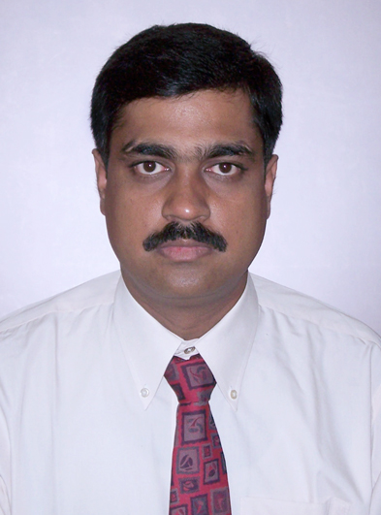
i. Name : PROF.(DR.) BHUPEN CHANDRA BEHERA  ii. Date of Birth : 12.06.1963  iii. Unique id: 458493597996  iv. Education Qualifications: M.Pharm, Ph.D  v. Designation: Professor & Head of department of Pharmaceutics  vi.Work Experience:  - Teaching: 34Years  - Research:  - Industry:  - Others:  vii. Area of Specialization : Pharmaceutics  viii. Courses taught at Diploma/Under Graduate/ Post Graduate: D.Pharm & B.Pharm  ix. Research guidance  - No. of papers published in National : 24  /International Journals/ Conferences  - Master:15  - Ph.D:  x. Projects Carried out: Nil  xi. Patents:Nil  xii. Technology Transfer:Nil  xiii. Research Publications:13  xiv. No. of Books published with details:Nil | 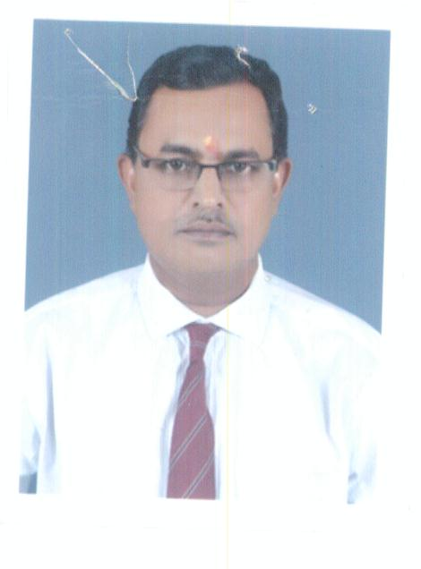

i. Name : PROF.(DR.) CHANDRA KANTI CHAKRABORTI  ii. Date of Birth : 13.08.1957  iii. Unique id: 9500365232  iv. Education Qualifications: M.Pharm, Ph.D  v. Designation: Professor & Head of department of Pharmacology  vi.Work Experience:  - Teaching: 35Years  - Research:  - Industry:  - Others:  vii. Area of Specialization : Pharmacology  viii. Courses taught at Diploma/Under Graduate/ Post Graduate: D.Pharm & B.Pharm  ix. Research guidance  - No. of papers published in National : 47  /International Journals/ Conferences  - Master:15  - Ph.D: 01  x. Projects Carried out: Nil  xi. Patents:Nil  xii. Technology Transfer:Nil  xiii. Research Publications:13  xiv. No. of Books published with details:Nil | 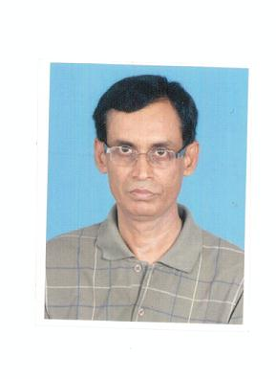
i. Name : Prof.(Dr.) Manoj Kumar Dalai  ii. Date of Birth : 15.06.1970  iii. Unique id: 901891018317  iv. Education Qualifications: M.Pharm, Ph.D  v. Designation: Professor & Head Pharmaceutical Chemistry  vi.Work Experience: 22 Years  - Teaching: 22 Years  - Research: 6 Years  - Industry: 3 Years  - Others:  vii. Area of Specialization: Pharma. Chemistry  viii. Courses taught at Diploma/Under Graduate/ Post Graduate: D. Pharm & B. Pharm  ix. Research guidance  - No. of papers published in National : 12  /International Journals/ Conferences  - Master - 02  - Ph.D - Nil  x. Projects Carried out: Nil  xi. Patents: Nil  xii. Technology Transfer: Nil  xiii. Research Publications: 12  xiv. No. of Books published with details: Nil | 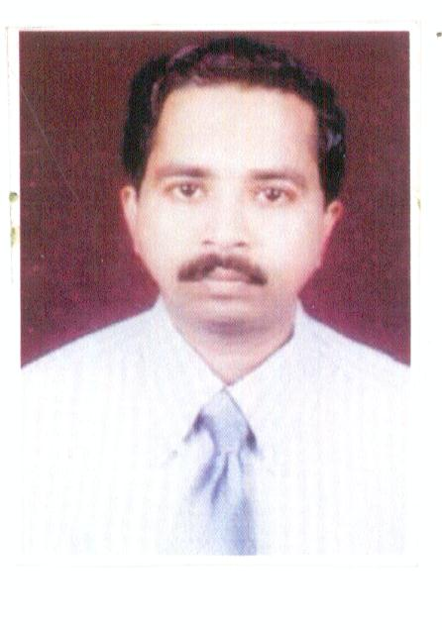
i. Name : Mr.Asok Samanta  ii. Date of Birth : 15.01.1958  iii. Unique id: 517257798941  iv. Education Qualifications: M.Pharm  v. Designation: Professor  vi.Work Experience: 27  - Teaching:  - Research:  - Industry:  - Others:  vii. Area of Specialization : Pharmaceutics  viii. Courses taught at Diploma/Under Graduate/ Post Graduate: B.Pharm & M.Pharm  ix. Research guidance  - No. of papers published in National :  /International Journals/ Conferences  - Master  - Ph.D  x. Projects Carried out:  xi. Patents:  xii. Technology Transfer:  xiii. Research Publications:  xiv. No. of Books published with details: | 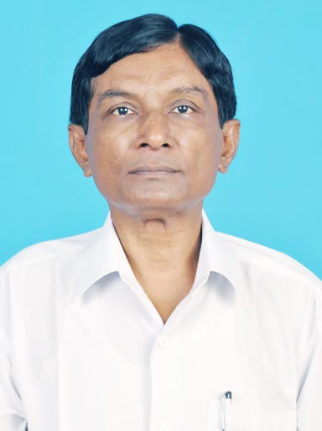
i. Name : Prof. (Dr.) (Mrs.) Subhashree Sahoo  ii. Date of Birth : 04.03.1977  iii. Unique id: 928986631121  iv. Education Qualifications: M.Pharm, Ph.D.  v. Designation: Professor & Head  vi.Work Experience:  - Teaching: 16 years  - Research:  - Industry:  - Others:  vii. Area of Specialization : Pharmaceutics  viii. Courses taught at Diploma/Under Graduate/ Post Graduate: B.Pharm & M.Pharm  ix. Research guidance  - No. of papers published in National : International Journals-39 and Conferences-05; Reviewer of three International Journals and Bentham Brand Ambassador  - Master - 10  - Ph.D – 02 (Continuing in BPUT)  x. Projects Carried out: Nil  xi. Patents: Nil  xii. Technology Transfer:  xiii. Research Publications: 39  xiv. No. of Books published with details: | 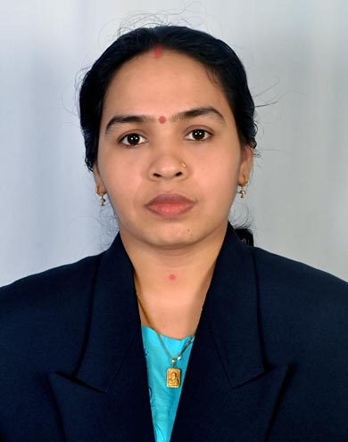
i. Name : Dr.Manoj Kumar Mahapatra  ii. Date of Birth : 02.06.1984  iii. Unique id: 932648405466  iv. Education Qualifications: M.Pharm, Ph.D  v. Designation: Associate Professor  vi.Work Experience:  - Teaching:06 years  - Research:04 years  - Industry:  - Others:  vii. Area of Specialization : Pharma. Chemistry  viii. Courses taught at Diploma/Under Graduate/ Post Graduate: D.Pharm & B.Pharm  ix. Research guidance  - No. of papers published in National :14  /International Journals/ Conferences  - Master  - Ph.D  x. Projects Carried out: Nil  xi. Patents: Nil  xii. Technology Transfer: Nil  xiii. Research Publications:14  xiv. No. of Books published with details: Nil | 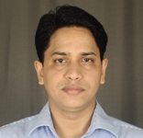
i. Name : Dr. Prakash Kumar Palai  ii. Date of Birth : 20.07.1975  iii. Unique id: 537351073221  iv. Education Qualifications: M. Pharm, Ph.D  v. Designation: Associate Professor  vi.Work Experience:  - Teaching: 2 years  - Research: 3 Years  - Industry:  - Others:  vii. Area of Specialization : Pharmaceutical Analysis & Quality Assurance  viii. Courses taught at Diploma/Under Graduate/ Post Graduate: D.Pharm, B.Pharm and M. Pharm  ix. Research guidance  No. of papers published in National/International Journals/ Conferences: 5  x. Projects Carried out:  xi. Patents:  xii. Technology Transfer:  xiii. Research Publications: 2  xiv. No. of Books published with detail: | 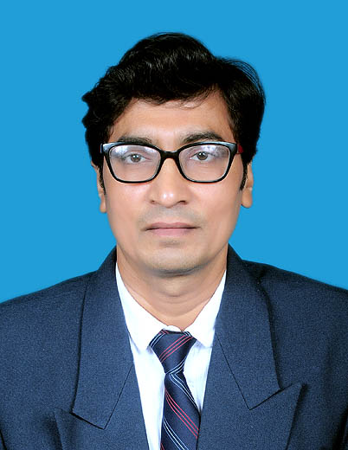
i. Name : Dr. Itishree Mohanty  ii. Date of Birth : 17.06.1976  iii. Unique id: 376640565250  iv. Education Qualifications: MBA, Ph.D  v. Designation: Associate Professor  vi.Work Experience:  - Teaching:13years  - Research:  - Industry:  - Others:  vii. Area of Specialization : Management  viii. Courses taught at Diploma/Under Graduate/ Post Graduate: D.Pharm & B.Pharm  ix. Research guidance  No. of papers published in National/International Journals/ Conferences: 34 Reviewer of two International Journals( Palgo Journals (ISSN 2476-8332),and IJournal (ISSN 2347-4890)  - Master: 06 (Under Sambalpur University)  - Ph.D-01  x. Projects Carried out:  xi. Patents:  xii. Technology Transfer:  xiii. Research Publications:34  xiv. No. of Books published with detail: (01) Effectiveness of Training in Organization Development, LAP LAMBERT Academic Publishing, Deutschland/Germany,ISBN:978-3-659-82674-0,2016. | 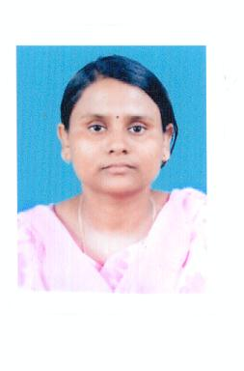
i. Name : MRS. SHARMISTHA NAIK  ii. Date of Birth : 12.05.1972  iii. Unique id: 712239520742  iv. Education Qualifications: Ph.D  v. Designation: Asssociate Professor  vi.Work Experience:  - Teaching: 20 Years  - Research:  - Industry:  - Others:  vii. Area of Specialization : Pharmaceutical Chemistry  viii. Courses taught at Diploma/Under Graduate/ Post Graduate: B.Pharm  ix. Research guidance  - No. of papers published in National :  /International Journals/ Conferences  - Master  - Ph.D  x. Projects Carried out:  xi. Patents:  xii. Technology Transfer:  xiii. Research Publications:  xiv. No. of Books published with details: | 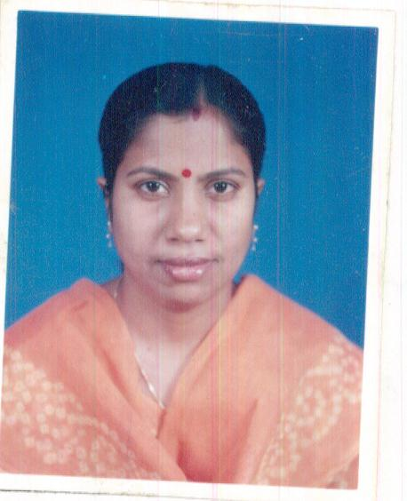
i. Name : Mr.Vikash Dash  ii. Date of Birth : 01.01.1980  iii. Unique id: 367901664292  iv. Education Qualifications: M.Pharm  v. Designation: Asst. Professor  vi. Work Experience:  - Teaching: 14 Years  - Research:  - Industry: 2 Years  - Others:  vii. Area of Specialization : Pharmaceutics  viii. Courses taught at Diploma/Under Graduate/ Post Graduate: D.Pharm & B.Pharm  ix. Research guidance  - No. of papers published in National :10  /International Journals/ Conferences  - Master  - Ph.D  x. Projects Carried out:  xi. Patents:  xii. Technology Transfer:  xiii. Research Publications:  xiv. No. of Books published with details: | 
i. Name : Miss. Sarojini Nayak  ii. Date of Birth : 03.07.1978  iii. Unique id: 986295644827  iv. Education Qualifications: M.Pharm  v. Designation: Asst. Professor  vi. Work Experience:  - Teaching: 15 Years  - Research:  - Industry:  - Others:  vii. Area of Specialization : Pharmacology  viii. Courses taught at Diploma/Under Graduate/ Post Graduate: D.Pharm, B.Pharm & M.Pharm  ix. Research guidance  - No. of papers published in National :03  /International Journals 14 / Conferences: 02  - Master: 05  - Ph.D  x. Projects Carried out:  xi. Patents: Nil  xii. Technology Transfer: Nil  xiii. Research Publications:17  xiv. No. of Books published with details: Nil | 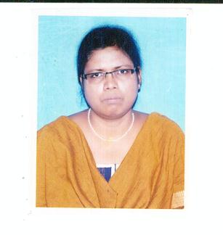
i. Name : Mrs. Anjulata Manjari Sahoo  ii. Date of Birth : 11.04.1975  iii. Unique id: 398768329962  iv. Education Qualifications: M.Pharm  v. Designation: Asst. Professor  vi. Work Experience:  - Teaching: 18 Years  - Research:  - Industry:  - Others:  vii. Area of Specialization : Pharma. Biotechnology  viii. Courses taught at Diploma/Under Graduate/ Post Graduate: D.Pharm & B.Pharm  ix. Research guidance  - No. of papers published in National :  /International Journals/ Conferences  - Master  - Ph.D  x. Projects Carried out:  xi. Patents:  xii. Technology Transfer:  xiii. Research Publications:  xiv. No. of Books published with details: | 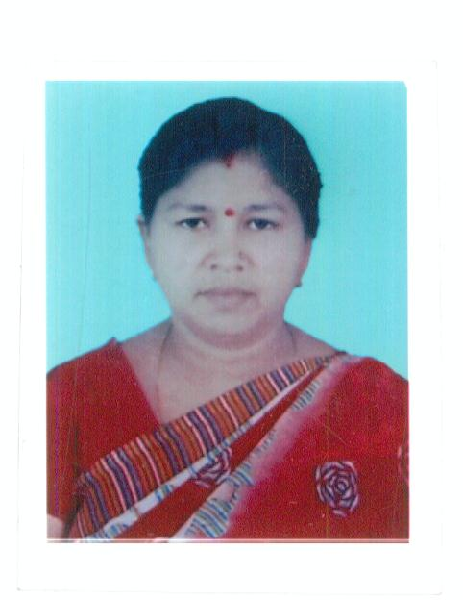
i. Name : Mrs. Manjari Tirkey  ii. Date of Birth : 23.09.1989  iii. Unique id: 222882961145  iv. Education Qualifications: M.Pharm  v. Designation: Asst. Professor  vi.Work Experience:  - Teaching: 06 Years  - Research:  - Industry:1 year  - Others:  vii. Area of Specialization : Pharmaceutics  viii. Courses taught at Diploma/Under Graduate/ Post Graduate: D.Pharm, B.Pharm & M.Pharm  ix. Research guidance  - No. of papers published in National :  /International Journals/ Conferences  - Master  - Ph.D  x. Projects Carried out:  xi. Patents:  xii. Technology Transfer:  xiii. Research Publications:  xiv. No. of Books published with details: | 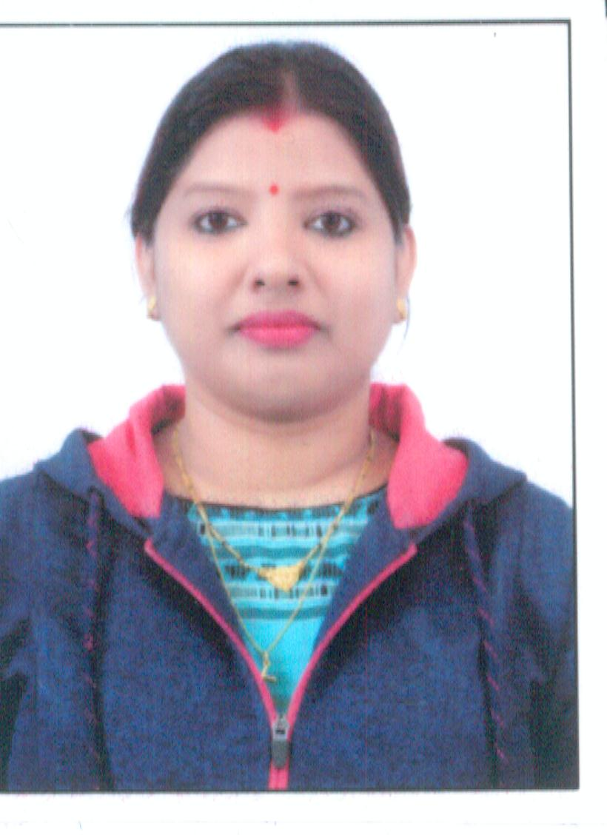
i. Name : : MR SUBHA NARAYAN MOHAPATRA  ii. Date of Birth : 13.02.1975  iii. Unique id: 943466935718  iv. Education Qualifications: M.Pharm  v. Designation: Asst. Professor  vi.Work Experience:  - Teaching: 09 Years  - Research:  - Industry: 10 years Years  - Others:  vii. Area of Specialization : Pharmaceutics  viii. Courses taught at Diploma/Under Graduate/ Post Graduate: D.Pharm ,B.Pharm& M.Pharm  ix. Research guidance  - No. of papers published in National :  /International Journals/ Conferences  - Master  - Ph.D  x. Projects Carried out:  xi. Patents:  xii. Technology Transfer:  xiii. Research Publications:  xiv. No. of Books published with details: | 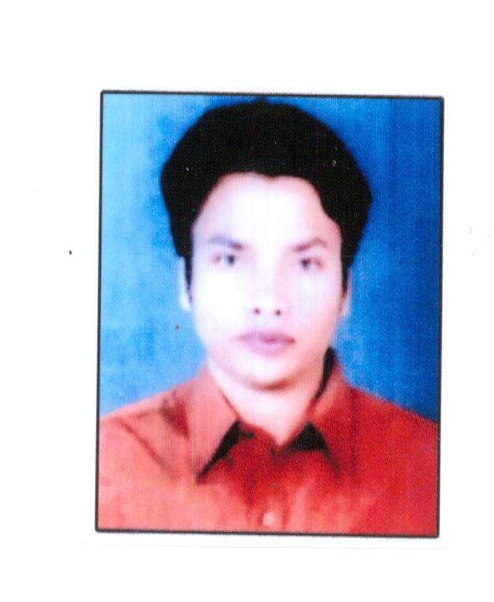
i. Name: MRS. BARSHA GIRI  ii. Date of Birth : 01.07.1988  iii. Unique id: 425676582190  iv. Education Qualifications: M.Pharm  v. Designation: Asst. Professor  vi. Work Experience:  - Teaching:07 Years  - Research:  - Industry:  - Others:  vii. Area of Specialization : Pharmacology  viii. Courses taught at Diploma/Under Graduate/ Post Graduate: D.Pharm, B.Pharm & M.Pharm  ix. Research guidance  - No. of papers published in National :  /International Journals/ Conferences  - Master  - Ph.D  x. Projects Carried out:  xi. Patents:  xii. Technology Transfer:  xiii. Research Publications:  xiv. No. of Books published with details: | 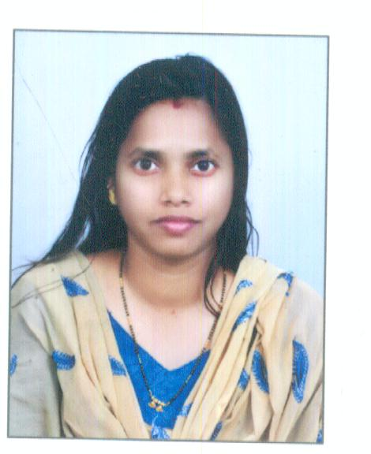
i. Name : MRS. PRIYA RASHMI CHOUDHURY  ii. Date of Birth : 12.06.1990  iii. Unique id:391979485857  iv. Education Qualifications: M.Pharm  v. Designation: Asst. Professor  vi.Work Experience:  - Teaching: 06 Years  - Research:  - Industry:  - Others:  vii. Area of Specialization : Pharmaceutical Analysis & Quality Assurance  viii. Courses taught at Diploma/Under Graduate/ Post Graduate: D.Pharm & B.Pharm  ix. Research guidance  - No. of papers published in National :  /International Journals/ Conferences  - Master  - Ph.D  x. Projects Carried out:  xi. Patents:  xii. Technology Transfer:  xiii. Research Publications:  xiv. No. of Books published with details: | 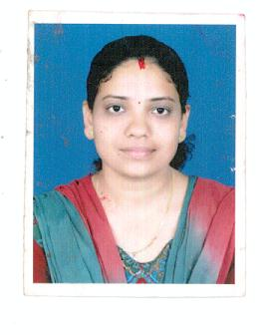
i. Name : MISS BINOJINI XESS  ii. Date of Birth : 03.03.1990  iii. Unique id: 7430644364  iv. Education Qualifications: M.Pharm  v. Designation: Asst. Professor  vi.Work Experience:03 Years  - Teaching:  - Research:  - Industry:  - Others:  vii. Area of Specialization : Pharmaceutics  viii. Courses taught at Diploma/Under Graduate/ Post Graduate: D.Pharm & B.Pharm  ix. Research guidance  - No. of papers published in National :  /International Journals/ Conferences  - Master  - Ph.D  x. Projects Carried out:  xi. Patents:  xii. Technology Transfer:  xiii. Research Publications:  xiv. No. of Books published with details: | 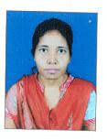
i. Name : MRS. GITANJALI PATANAIK  ii. Date of Birth : 19.06.1984  iii. Unique id: 250139536903  iv. Education Qualifications: M.Pharm  v. Designation: Asst. Professor  vi.Work Experience:  - Teaching: 03 Years  - Research:  - Industry:  - Others:  vii. Area of Specialization : Pharmachemistry  viii. Courses taught at Diploma/Under Graduate/ Post Graduate: D.Pharm & B.Pharm  ix. Research guidance  - No. of papers published in National :  /International Journals/ Conferences  - Master  - Ph.D  x. Projects Carried out:  xi. Patents:  xii. Technology Transfer:  xiii. Research Publications:  xiv. No. of Books published with details: | 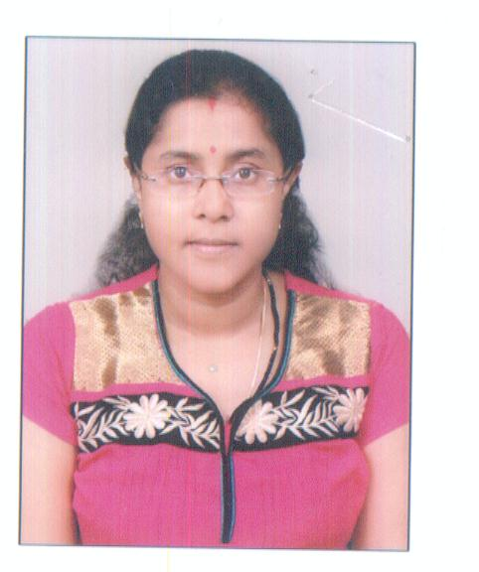
i. Name : MR. ROHIT AGARWAL  ii. Date of Birth : 18.05.1987  iii. Unique id: 893320507153  iv. Education Qualifications: M.Pharm  v. Designation: Asst. Professor  vi.Work Experience: 03 Years  - Teaching:  - Research:  - Industry:04 years  - Others:  vii. Area of Specialization : Pharmaceutics  viii. Courses taught at Diploma/Under Graduate/ Post Graduate: D.Pharm & B.Pharm  ix. Research guidance  - No. of papers published in National :02  /International Journals/ Conferences  - Master  - Ph.D  x. Projects Carried out:  xi. Patents:  xii. Technology Transfer:  xiii. Research Publications:  xiv. No. of Books published with details: | 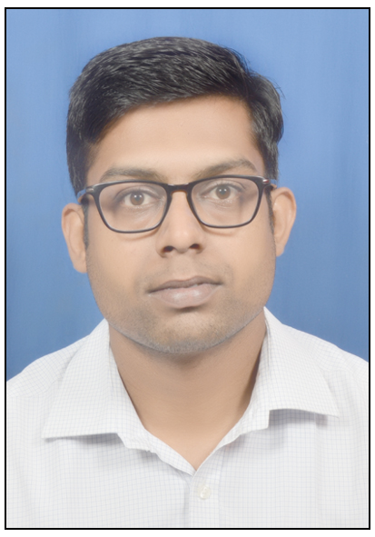
i. Name : MISS. SWAYAMPRAVA MISHRA  ii. Date of Birth : 15.05.1984  iii. Unique id: 231951275828  iv. Education Qualifications: M.Pharm, Ph.D(Continuing)  v. Designation: Asst. Professor  vi.Work Experience:  - Teaching: 14 Years  - Research:  - Industry:  - Others:  vii. Area of Specialization : Pharmaceutics  viii. Courses taught at Diploma/Under Graduate/ Post Graduate: D.Pharm, B.Pharm & M.Pharm  ix. Research guidance  - No. of papers published in National : Nil  /International Journals/ Conferences  - Master  - Ph.D  x. Projects Carried out: Nil  xi. Patents: Nil  xii. Technology Transfer: Nil  xiii. Research Publications: Nil  xiv. No. of Books published with details: Nil | 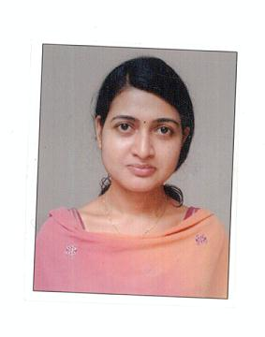
i. Name : MR. SUNIL KUMAR  ii. Date of Birth : 15.01.1990  iii. Unique id: 504880829331  iv. Education Qualifications: M.Pharm  v. Designation: Asst. Professor  vi.Work Experience:  - Teaching: 03 Years  - Research:  - Industry:  - Others:  vii. Area of Specialization : Pharmacetics  viii. Courses taught at Diploma/Under Graduate/ Post Graduate: D.Pharm & B.Pharm  ix. Research guidance  - No. of papers published in National :  /International Journals/ Conferences  - Master  - Ph.D  x. Projects Carried out:  xi. Patents:  xii. Technology Transfer:  xiii. Research Publications:  xiv. No. of Books published with details: | 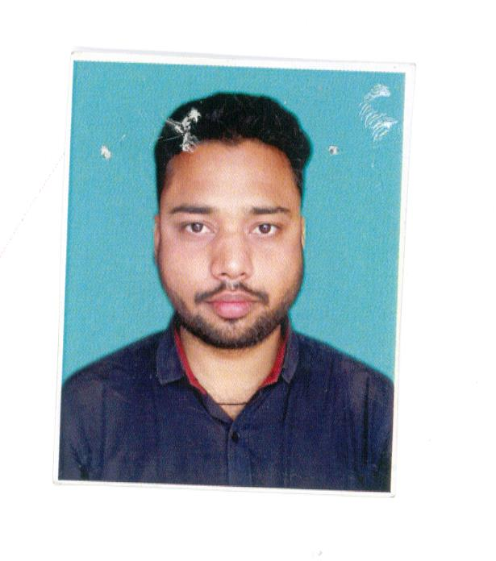
i. Name : MR. CHANDAN BERA  ii. Date of Birth : 13.11.1985  iii. Unique id: 311527780252  iv. Education Qualifications: M.Pharm  v. Designation: Asst. Professor  vi.Work Experience:  - Teaching: 04 Years  - Research:  - Industry:  - Others:  vii. Area of Specialization : Pharmaceutics  viii. Courses taught at Diploma/Under Graduate/ Post Graduate: D.Pharm & B.Pharm  ix. Research guidance  - No. of papers published in National :  /International Journals/ Conferences  - Master  - Ph.D  x. Projects Carried out:  xi. Patents:  xii. Technology Transfer:  xiii. Research Publications:  xiv. No. of Books published with details: | 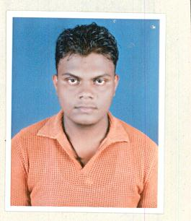
i. Name : MR. AJEET KUMAR  ii. Date of Birth : 13.11.1985  iii. Unique id: 311527780252  iv. Education Qualifications: M.Pharm  v. Designation: Asst. Professor  vi.Work Experience:  - Teaching: 04 Years  - Research:  - Industry:  - Others:  vii. Area of Specialization : Physical Pharmaceutics  viii. Courses taught at Diploma/Under Graduate/ Post Graduate: D.Pharm & B.Pharm  ix. Research guidance  - No. of papers published in National :  /International Journals/ Conferences  - Master  - Ph.D  x. Projects Carried out:  xi. Patents:  xii. Technology Transfer:  xiii. Research Publications:  xiv. No. of Books published with details: | 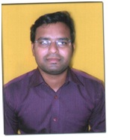
i. Name : MR. NITAI GOPAL  ii. Date of Birth : 10.06.1994  iii. Unique id: 585413765820  iv. Education Qualifications: M.Pharm  v. Designation: Asst. Professor  vi.Work Experience:  - Teaching: 4 Years  - Research:  - Industry:  - Others:  vii. Area of Specialization : Pharmaceutics  viii. Courses taught at Diploma/Under Graduate/ Post Graduate: D.Pharm & B.Pharm  ix. Research guidance  - No. of papers published in National :  /International Journals/ Conferences  - Master  - Ph.D  x. Projects Carried out:  xi. Patents:  xii. Technology Transfer:  xiii. Research Publications:  xiv. No. of Books published with details: | 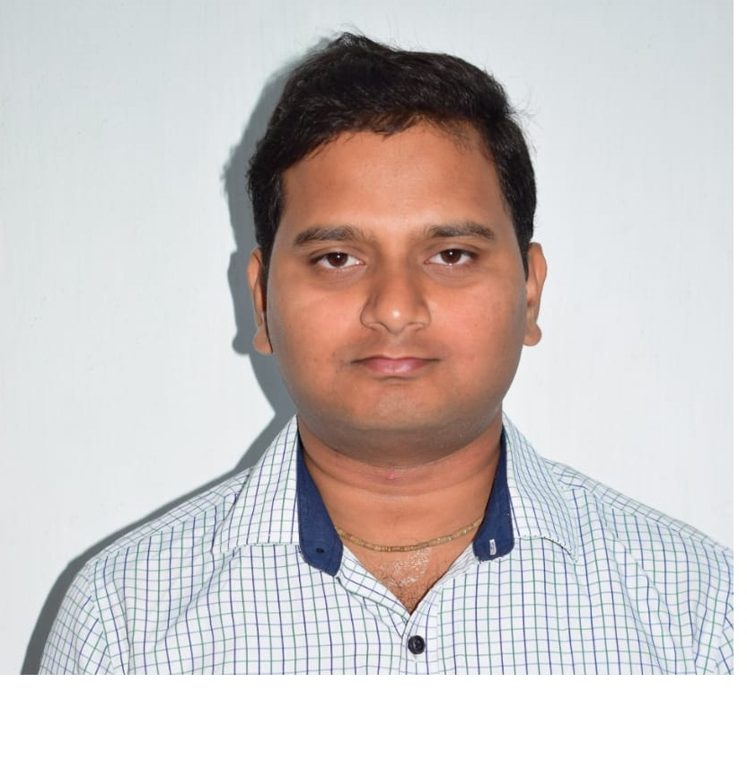
i. Name : MISS. KRISHNA KUMBHA  ii. Date of Birth : 11.07.1990  iii. Unique id: 437779308988  iv. Education Qualifications: M.Pharm  v. Designation: Asst. Professor  vi.Work Experience:  - Teaching: 01 Years  - Research:  - Industry:  - Others:  vii. Area of Specialization : Pharmacognosy and Phytochemistry - I  viii. Courses taught at Diploma/Under Graduate/ Post Graduate: D.Pharm & B.Pharm  ix. Research guidance  - No. of papers published in National :  /International Journals/ Conferences  - Master  - Ph.D  x. Projects Carried out:  xi. Patents:  xii. Technology Transfer:  xiii. Research Publications:  xiv. No. of Books published with details: | 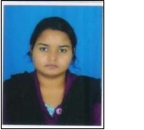
i. Name : MISS. SUBHALAXMI MAHATO  ii. Date of Birth : 19.05.1996  iii. Unique id: 290977288093  iv. Education Qualifications: M.Pharm  v. Designation: Asst. Professor  vi.Work Experience:  - Teaching: Less than 02 years  - Research:  - Industry:  - Others:  vii. Area of Specialization : Pharmaceutics  viii. Courses taught at Diploma/Under Graduate/ Post Graduate: D.Pharm, B.Pharm  ix. Research guidance  - No. of papers published in National :Nil  /International Journals/ Conferences  - Master  - Ph.D  x. Projects Carried out: Nil  xi. Patents: Nil  xii. Technology Transfer: Nil  xiii. Research Publications: Nil  xiv. No. of Books published with details: Nil | 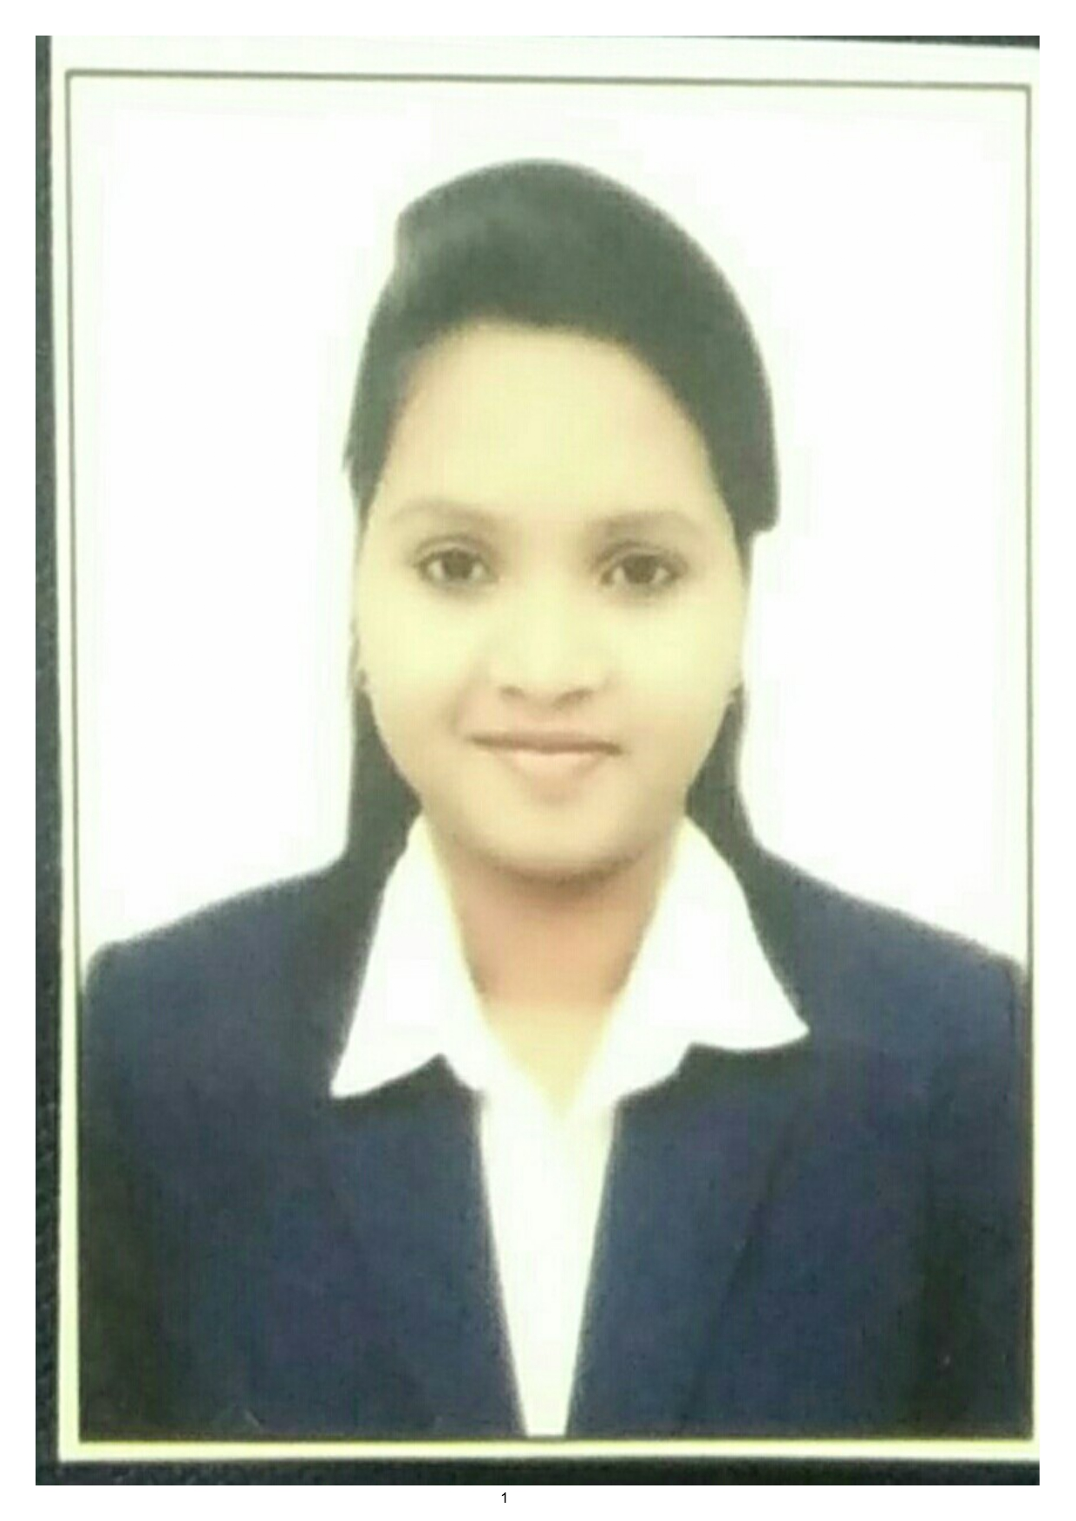
i. Name : MISS. ADYASA MOHANTY  ii. Date of Birth : 17.04.1989  iii. Unique id: 7430740616  iv. Education Qualifications: M.Pharm  v. Designation: Asst. Professor  vi.Work Experience:  - Teaching:  - Research:  - Industry: 02 years  - Others:  vii. Area of Specialization : Pharmaceutics  viii. Courses taught at Diploma/Under Graduate/ Post Graduate: D.Pharm  ix. Research guidance  - No. of papers published in National : Nil  /International Journals/ Conferences  - Master  - Ph.D  x. Projects Carried out: Nil  xi. Patents: Nil  xii. Technology Transfer: Nil  xiii. Research Publications: Nil  xiv. No. of Books published with details: Nil | 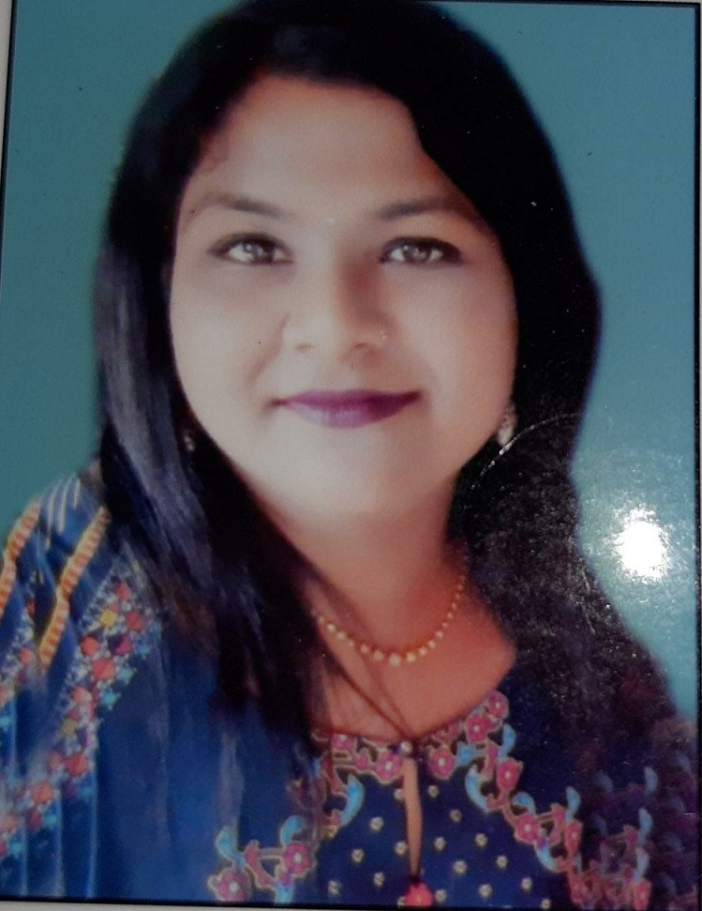
i. Name : MR. NILURAM PARIDA  ii. Date of Birth : 16.06.1976  iii. Unique id: 937615985222  iv. Education Qualifications: M.Sc (Chemistry), AIC  v. Designation: Asst. Professor  vi.Work Experience:  - Teaching: 21 Years  - Research:  - Industry:  - Others:  vii. Area of Specialization : Chemistry  viii. Courses taught at Diploma/Under Graduate/ Post Graduate: B.Pharm  ix. Research guidance  - No. of papers published in National :01  /International Journals/ Conferences  - Master  - Ph.D  x. Projects Carried out: Nil  xi. Patents: Nil  xii. Technology Transfer: Nil  xiii. Research Publications:01  xiv. No. of Books published with details: Nil | 
i. Name : MR. BASANT KUMAR DAS  ii. Date of Birth : 09.07.1972  iii. Unique id: 792762853015  iv. Education Qualifications: M.Phil  v. Designation: Asst. Professor  vi.Work Experience:  - Teaching:19 Years  - Research:  - Industry:  - Others:  vii. Area of Specialization : Mathematics  viii. Courses taught at Diploma/Under Graduate/ Post Graduate: B.Pharm  ix. Research guidance  - No. of papers published in National :  /International Journals/ Conferences  - Master  - Ph.D  x. Projects Carried out:  xi. Patents:  xii. Technology Transfer:  xiii. Research Publications:  xiv. No. of Books published with details: | 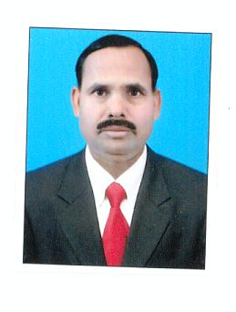
i. Name : MRS. RITUSMITA ROUTRAY  ii. Date of Birth : 07.02.1978  iii. Unique id: 373502743768  iv. Education Qualifications: M. Pharm  v. Designation: Asst. Professor  vi. Work Experience:  - Teaching: 05 Years  - Research:  - Industry:  - Others:  vii. Area of Specialization : Pharmacology  viii. Courses taught at Diploma/Under Graduate/ Post Graduate: D.Pharm & B.Pharm  ix. Research guidance  - No. of papers published in National :  /International Journals/ Conferences  - Master  - Ph.D  x. Projects Carried out:  xi. Patents:  xii. Technology Transfer:  xiii. Research Publications:  xiv. No. of Books published with details: | 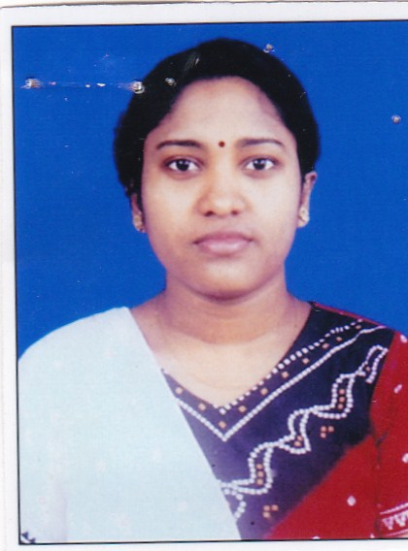
i. Name : MISS. SRITI KAYAL  ii. Date of Birth : 01.01.1982  iii. Unique id: 854980294288  iv. Education Qualifications:  v. Designation: Asst. Professor  vi.Work Experience:  - Teaching: 02 Years  - Research: 03 Years  - Industry:  - Others:  vii. Area of Specialization :  viii. Courses taught at Diploma/Under Graduate/ Post Graduate: D.Pharm & B.Pharm  ix. Research guidance  - No. of papers published in National :  /International Journals/ Conferences  - Master  - Ph.D  x. Projects Carried out:  xi. Patents:  xii. Technology Transfer:  xiii. Research Publications:  xiv. No. of Books published with details: | 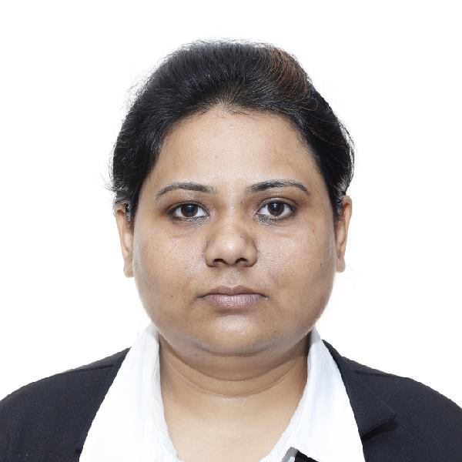
i. Name : MRS. YOGABHANJANA DASH  ii. Date of Birth : 10.05.1987  iii. Unique id: 85928565844  iv. Education Qualifications: MA (English)  v. Designation: Asst. Professor  vi.Work Experience:  - Teaching: 02 Years  - Research:  - Industry:  - Others:  vii. Area of Specialization :  viii. Courses taught at Diploma/Under Graduate/ Post Graduate: B.Pharm  ix. Research guidance  - No. of papers published in National :  /International Journals/ Conferences  - Master  - Ph.D  x. Projects Carried out:  xi. Patents:  xii. Technology Transfer:  xiii. Research Publications:  xiv. No. of Books published with details: | 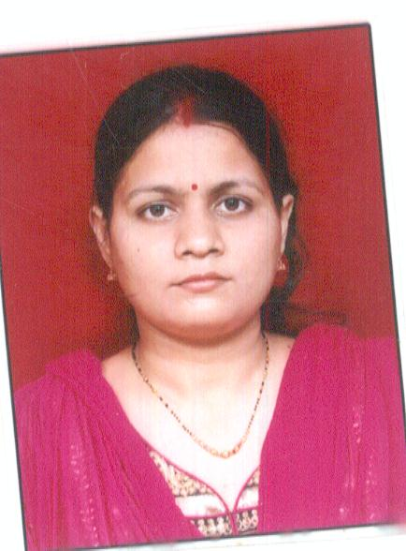

i. Name : MISS. PREETY DEY  ii. Date of Birth : 07.07.1995  iii. Unique id: 7431265052  iv. Education Qualifications: M. Pharm  v. Designation: Asst. Professor  vi.Work Experience:  - Teaching: 03 Years  - Research:  - Industry:  - Others:  vii. Area of Specialization : Pharmacology  viii. Courses taught at Diploma/Under Graduate/ Post Graduate: D.Pharm & B.Pharm  ix. Research guidance  - No. of papers published in National :  /International Journals/ Conferences  - Master  - Ph.D  x. Projects Carried out:  xi. Patents:  xii. Technology Transfer:  xiii. Research Publications:  xiv. No. of Books published with details: | 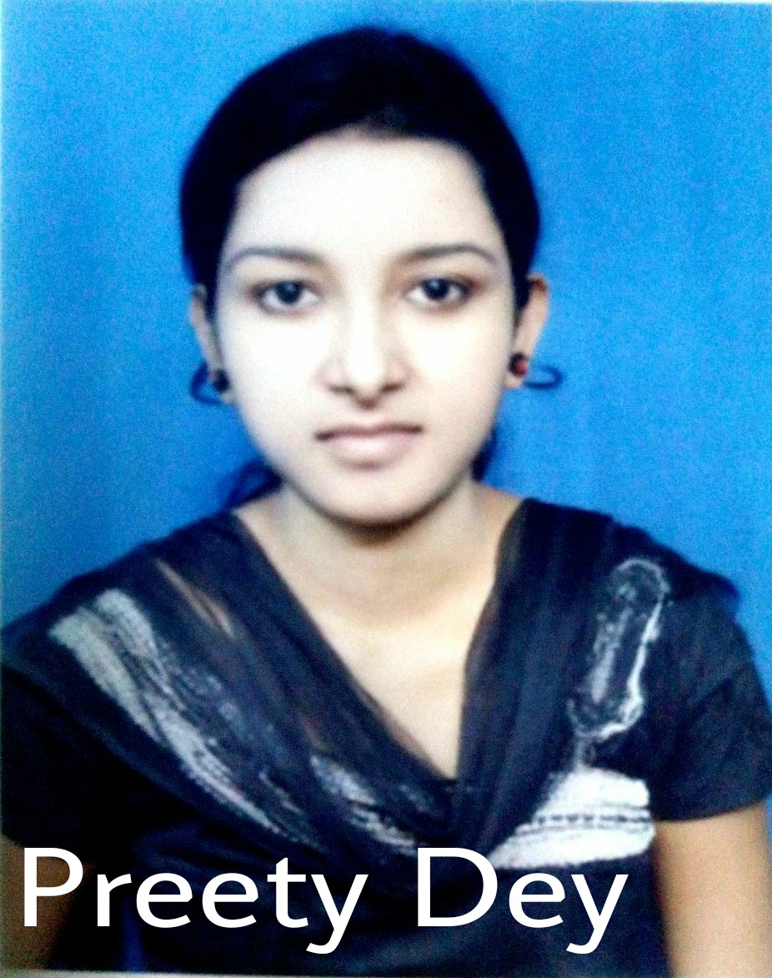
i. Name : MR. ASISH KUMAR ASHU  ii. Date of Birth : 15.12.1977  iii. Unique id: 7431083030  iv. Education Qualifications: B. Pharm  v. Designation: Lecturer  vi.Work Experience:  - Teaching: 03 Years  - Research:  - Industry:  - Others:  vii. Area of Specialization :  viii. Courses taught at Diploma/Under Graduate/ Post Graduate: D.Pharm  ix. Research guidance  - No. of papers published in National :  /International Journals/ Conferences  - Master  - Ph.D  x. Projects Carried out:  xi. Patents:  xii. Technology Transfer:  xiii. Research Publications:  xiv. No. of Books published with details: | 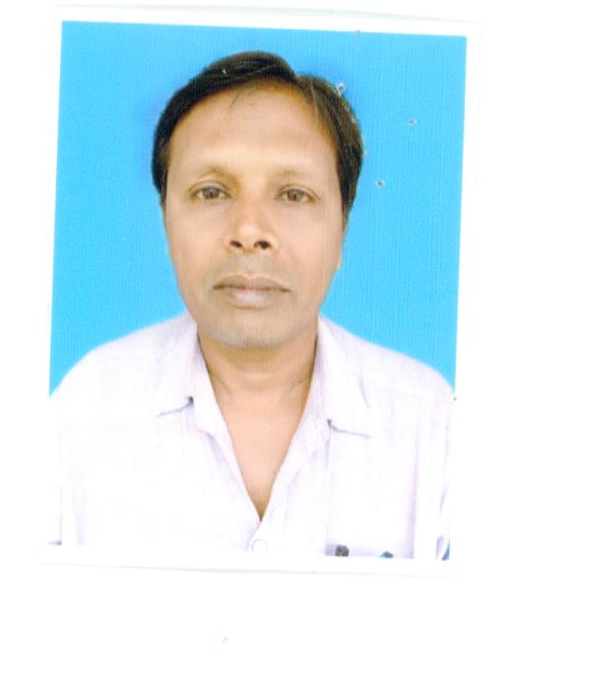
i. Name : MISS. PRIYANKA NAYAK  ii. Date of Birth : 02.06.1997  iii. Unique id: 491861634753  iv. Education Qualifications: M. Pharm  v. Designation: Asst. Professor  vi.Work Experience:  - Teaching: 01 Years  - Research:  - Industry:  - Others:  vii. Area of Specialization : Pharmacology  viii. Courses taught at Diploma/Under Graduate/ Post Graduate: D.Pharm & B.Pharm:- D. Pharm  ix. Research guidance  - No. of papers published in National :  /International Journals/ Conferences  - Master  - Ph.D  x. Projects Carried out:  xi. Patents:  xii. Technology Transfer:  xiii. Research Publications:  xiv. No. of Books published with details: | 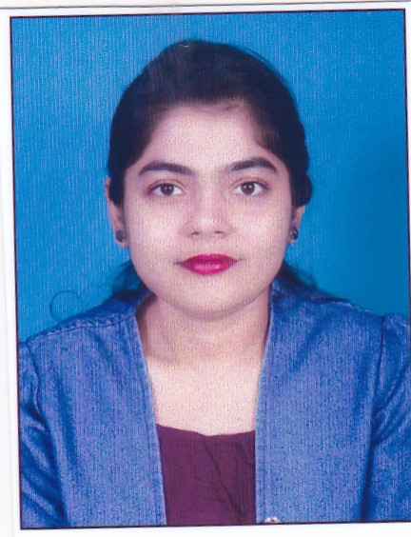
i. Name : MISS NIBEDITA DAS  ii. Date of Birth : 01.03.1997  iii. Unique id: 384592784032  iv. Education Qualifications: M. Pharm  v. Designation: Asst. Professor  vi.Work Experience:  - Teaching: 01 Year  - Research:  - Industry:  - Others:  vii. Area of Specialization : Pharmacology  viii. Courses taught at Diploma/Under Graduate/ Post Graduate: D.Pharm  ix. Research guidance  - No. of papers published in National :  /International Journals/ Conferences  - Master  - Ph.D  x. Projects Carried out:  xi. Patents:  xii. Technology Transfer:  xiii. Research Publications:  xiv. No. of Books published with details: | 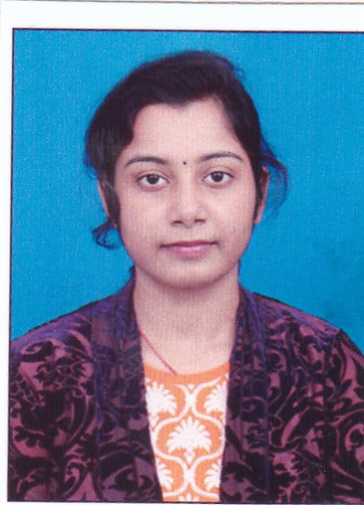
i. Name : MISS. SAISTHA ANJUM  ii. Date of Birth : 27.10.1996  iii. Unique id: 640555199331  iv. Education Qualifications: M. Pharm  v. Designation: Asst. Professor  vi.Work Experience:  - Teaching: 01 Years  - Research:  - Industry:  - Others:  vii. Area of Specialization : Pharmacology  viii. Courses taught at Diploma/Under Graduate/ Post Graduate: D.Pharm & B.Pharm:- D. Pharm  ix. Research guidance  - No. of papers published in National :  /International Journals/ Conferences  - Master  - Ph.D  x. Projects Carried out:  xi. Patents:  xii. Technology Transfer:  xiii. Research Publications:  xiv. No. of Books published with details: | 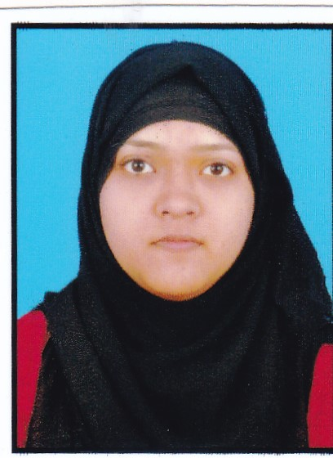
i. Name : MR. SUDHANSU SENAPATI  ii. Date of Birth : 13.02.1997  iii. Unique id: 804779868890  iv. Education Qualifications: M. Pharm  v. Designation: Asst. Professor  vi.Work Experience:  - Teaching: 01 Year  - Research:  - Industry:  - Others:  vii. Area of Specialization : Pharmacology  viii. Courses taught at Diploma/Under Graduate/ Post Graduate: D.Pharm  ix. Research guidance  - No. of papers published in National :  /International Journals/ Conferences  - Master  - Ph.D  x. Projects Carried out:  xi. Patents:  xii. Technology Transfer:  xiii. Research Publications:  xiv. No. of Books published with details: | 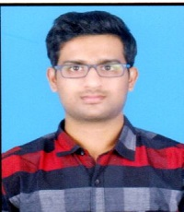
i. Name : MISS. SUSHREE RATNAMALA PATRA  ii. Date of Birth : 26.12.1997  iii. Unique id: 270888272861  iv. Education Qualifications: M. Pharm  v. Designation: Asst. Professor  vi.Work Experience:  - Teaching: 01 Years  - Research:  - Industry:  - Others:  vii. Area of Specialization : Pharmacology  viii. Courses taught at Diploma/Under Graduate/ Post Graduate: D.Pharm & B.Pharm:- D. Pharm  ix. Research guidance  - No. of papers published in National :  /International Journals/ Conferences  - Master  - Ph.D  x. Projects Carried out:  xi. Patents:  xii. Technology Transfer:  xiii. Research Publications:  xiv. No. of Books published with details: | 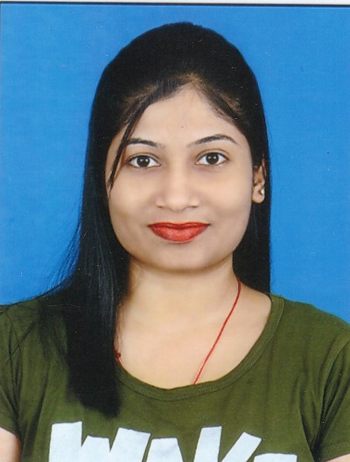

9. FEE

- Details of fee, as approved by State Fee Committee, for the Institution.
B.Pharm-62,500/-per annum, M. Pharm 73,000/- Per annum and D. Pharm 55,000/- Per annum.
- Time schedule for payment of fee for the entire programme.
31st July-odd semester and 31st December –even semester
- No. of Fee waivers granted with amount and name of students-As decided by State Govt. under TFW category for B. Pharm course only.
- Number of scholarships offered by the institute with the name of students, duration and amount- Nil
- Criteria for fee waivers/scholarships.-NA
- Estimated cost of Boarding and Lodging in Hostels:
Hostel fees:- Rs.14,000/-Per Annum.

10. ADMISSION

Branch | No. of seats sanctioned with the year of Approval | No. of students admitted under various categories each year in last three years | No. of applications received during last two years for admission under management Quota and number admitted
 |  |  | No. of applications received | No. of admitted
M.Pharm(Ph.Ceutics) | 18(2019-2020) | 06 | As per OJEE Admission criteria
M.Pharm(Ph.Ceutics) | 18 (2020-2021) | 09
M.Pharm(Ph.Ceutics) | 18 (2021-2022) | 15
M.Pharm(Ph.cology) | 18(2019-2020) | 09
M.Pharm(Ph.cology) | 18 (2020-2021) | 07
B.Pharm | 100(2019-2020) | 104+10 (L.E)
B.Pharm | 100 (2020-2021) | 105+10 (L.E)
B.Pharm | 100 (2021-2022) | 105+11(L.E)
D.Pharm | 60(2019-2020) | 58 | As per State Govt. Admission criteria and Sanctioned PCI intake
D.Pharm | 60(2020-2021) | 60
D.Pharm | 60(2021-2022) | 60

11. ADMISSION PROCEDURE
- Mention the admission test being followed, name and address of the Test Agency and its URL (website).- www.ojee.nic.in, www.dmetodisha.gov.in
- Number of seats allotted to different Test Qualified candidates Separately [AIEEE/CET(State conducted test/University test)/Association conducted test]
D. Pharm- 60
B.Pharm-100+05(TFW)
M.Pharm(Ph.Ceutics)-18
M.Pharm(Ph.Cology)-18
Calendar for admission against management/Vacant seats:
  - Last date for request for applications- As per OJEE/ State Govt. Notification
  - Last date for submission of application- As per OJEE/ State Govt. Notification
  - Dates for announcing final results- As per OJEE/ State Govt. Notification
  - Release of admission list (main list and waiting list should be announced on the same day)- As per OJEE/ State Govt. Notification
  - Date for acceptance by the candidate (time given should in no case be less than 15 days)- As per OJEE/ State Govt. Notification
  - Last date for closing of admission- As per OJEE/ State Govt. Notification
  - Starting of the Academic session.-As per University/OSBP Notification
  - The waiting list should be activated only on the expiry of date of main list- As per OJEE/ State Govt. Notification
  - The policy of refund of the fee, in case of withdrawal, should be clearly notified.- As per OJEE/ State Govt. Notification
12. CRITERIA AND WEIGHTAGES FOR ADMISSION
- Describe each criteria with its respective weightage i.e. Admission Test,
marks in qualifying examination etc.- As per OJEE/ State Govt. Notification
- Mention the minimum level of acceptance, if any,- As per norms
- Mention the cut-off levels of percentage & percentile scores of the candidates in the admission test for the last three years – As per OJEE/ State Govt. Notification
- Display marks scored in Test etc. and in aggregate for all candidates who were admitted.-Refer OJEE and DMET website.

13. LIST OF APPLICANTS
List of candidate whose applications have been received along with percentile/percentage score for each of the qualifying examination in separate categories for open seats. List of candidate who have applied along with percentage and percentile score for Management quota seats-
Refer OJEE (www.ojee.nic.in) and DMET (www.dmetodisha.gov.in) website.
14. Results of Admission Under Management seats/Vacant seats- As per OJEE, Odisha and
State Govt. Guidelines.
  - Composition of selection team for admission under Management Quota with the brief profile of
members (This information be made available in the public domain after the admission process is
over): As per OJEE/ State Govt. Guidelines
- Score of the individual candidate admitted arranged in order or merit
- List of candidate who have been offered admission
- Waiting list of the candidate in order of merit to be operative from the last date of joining of the first list candidate
- List of the candidate who joined within the date, vacancy position in each category before operation of waiting list

- INFORMATION ON INFRASTRUCTURE AND OTHER RESOURCES AVAILABLE.
- Number of Classrooms and size of each-Diploma-02(66Sq.m each), UG –04(100 Sq.m each),
PG –03(66 Sq.m each)
- Number of Tutorial rooms and size of each-UG-03(33Sq.m each), Diploma-02-(33 Sq.m each)
- Number of laboratories and size of each-19 (75Sq.m)
- Number of drawing halls with capacity of each-01(75Sq.m)
- Number of computer centers with capacity of each-01and 50 seating capacity
- Central Examination Facility, Number of rooms and capacity of each teaching learning process-10, 60 each
- Barrier Free Built Environment for disabled and elderly persons- No
- Occupancy Certificate: Yes
- Fire and Safety Certificate: Yes
- Hostel Facilities: Yes

LIBRARY:
- Number of library books/titles/journals available (Programme-wise)-
No. of Library books- 12750
No. of Titles- 2950
No. of Journals:
National & International- 68
- List of online National/International journals subscribed- Yes
- E-Library facilities- No
- LABORATORY AND WORKSHOP:
  - List of Major Equipment/Facilities- As per PCI norms.
  - List of Experimental Setup- As per BPUT/PCI syllabus
  - COMPUTING FACILITIES:
  - Internet bandwidth- 32MBPS
  - Number and configuration of System- 80Nos.
  - Total number of systems connected by LAN- 80 Nos.
  - Total number of systems connected to WAN- Nil
  - Major software packages available- Window-98, Office-2000, Q.Basic
C,C++,Window-XP
  - Special purpose facilities available:- Yes
  - Innovation Cell- Yes
  - Social Media Cell-
  - Compliance of the National Academic Depository (NAD), applicable to PGCM/ PGDM Institutions and University Departments

  - LIST OF FACILITIES AVAILABLE
Games and sports facilities-Football, Cricket, Volleyball, Badminton & Atheletics
Extra- Curricular Activities-Debate, Essay writing, Song& Technical aptitude test
Soft skill Development Facilities-Personality Development Course

- TEACHING LEARNING PROCESS
  - Curricula and syllabus for each of the Programmes as approved by the University: As per BPUT, Odisha
  - Academic Calendar of the University-As displayed in BPUT website
  - Academic Time Table- As per institute’s Time Table
  - Teaching Load of each Faculty- As per PCI/AICTE norms
  - Internal Continuous Evaluation System and place-Institute
  - Student’s assessment of Faculty, system in place-Institute

  - For each Post Graduate Courses give the following:
  - Title of the Course: M.Pharm (Pharmaceutics and Pharmacology)
  - Curricula and Syllabi: As per BPUT syllabus
  - Laboratory facilities exclusive to the Post Graduate Course: Yes
  - Special Purpose
  - Software, all design tools in case
  - Academic Calendar and frame work: As per BPUT Calender

- Enrollment of students in the last 3 years
Branch | No. of seats sanctioned with the year of Approval | No. of students admitted under various categories each year in last three years
M.Pharm(Ph.Ceutics) | 18(2019-2020) | 06
M.Pharm(Ph.Ceutics) | 18 (2020-2021) | 09
M.Pharm(Ph.Ceutics) | 18 (2021-2022) | 15
M.Pharm(Ph.cology) | 18(2019-2020) | 09
M.Pharm(Ph.cology) | 18 (2020-2021) | 07
B.Pharm | 100(2019-2020) | 104+10 (L.E)
B.Pharm | 100 (2020-2021) | 105+10 (L.E)
B.Pharm | 100 (2021-2022) | 105+11(L.E)
D.Pharm | 60(2019-2020) | 58
D.Pharm | 60(2020-2021) | 60
D.Pharm | 60(2021-2022) | 60

17. List of Research Projects/ Consultancy Works
  - Number of Projects carried out, funding agency, Grant received: Nil
  - Publications (if any) out of research in last three years out of masters projects: Nil
  - Industry Linkage: Nil
  - MoUs with Industries (minimum 3): Yes
18. LOA and subsequent EOA till the current Academic Year: LoA and subsequent EoA
19. Accounted audited statement for the last three years: Audit Report
20. Best Practices adopted, if any

Note: Suppression and/or misrepresentation of information shall invite appropriate penal action.
The Website shall be dynamically updated with regard to Mandatory Disclosures

